LAB221 Assignment | Type: | Short Assignment
 | Code: | J2.S.P0102
 | LOC: | 50
 | Slot(s): | 1

Title
Create a digital clock
Background Context
NA

Program Specifications
Create a program simulate a digital clock

Function details:

Display current time on the form in format: hh:mm:ss
Expectation of User interface:
The screen should be as:

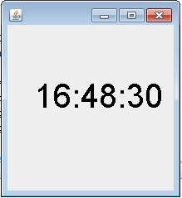

Guidelines

